EXPERIMENT 4
Ex. No.: 4
Analysis of SWR Pattern in High-Frequency Transmission Lines by Varying Load and Characteristic Impedance
AIM: To analyse the standing wave ratio (SWR) of a high-frequency transmission line by varying the load impedance and the characteristic impedance using Scilab.
SOFTWARE REQUIRED: Scilab 6.1.1

PROGRAM
clear; clc;
Z0=50; ZL=100+%i*0;
K=(ZL-Z0)/(ZL+Z0); rho=abs(K);
S=(1+rho)/(1-rho);
printf("Reflection coefficient magnitude = %.4f\n",rho);
printf("Standing Wave Ratio (SWR) = %.4f\n",S);
TEST CASES AND OUTPUT
Test Case 1: Z0=50 Ω, ZL=100 Ω
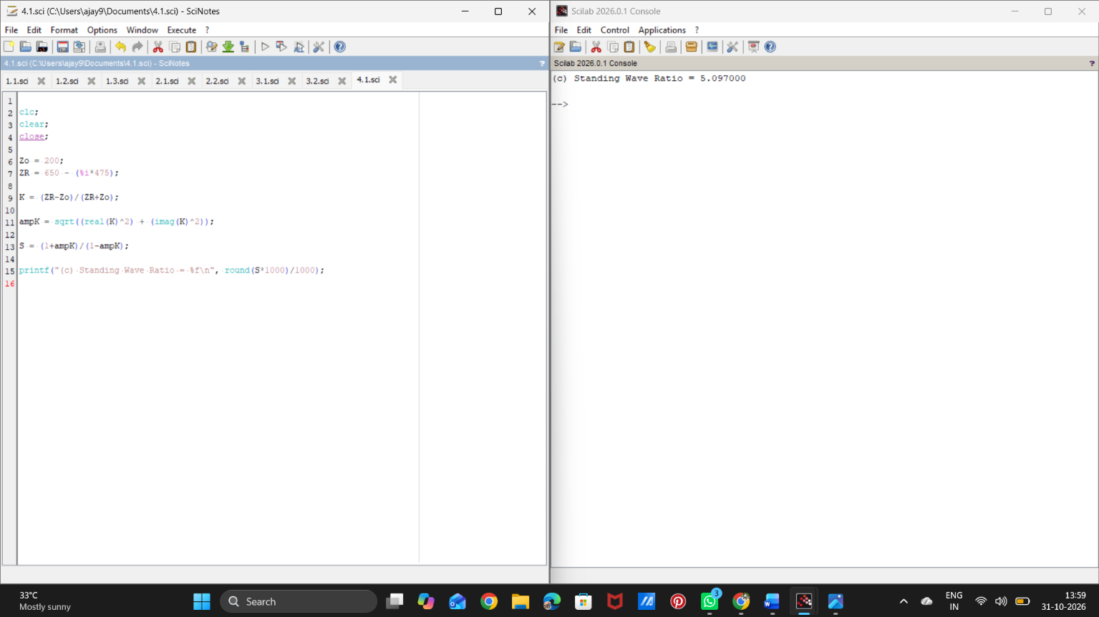

Test Case 2: Z0=50 Ω, ZL=75 Ω
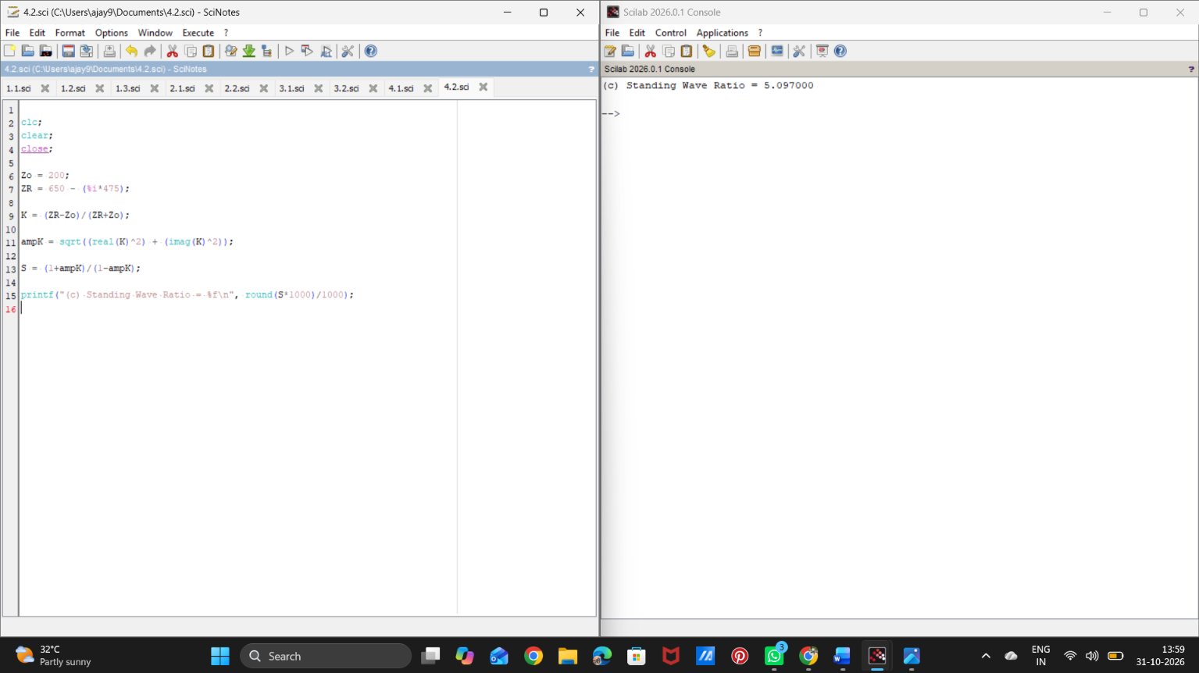

RESULT
Thus, the reflection coefficient and SWR were calculated for different load and characteristic impedances using Scilab.

